YENEPOYA (Deemed To Be University)



# FINAL PROJECT REPORT

**On**

**PHISHING EMAIL DETECTION USING AI**

**Submitted by:**

**TEAM: Crptify**

**LH-18**

**TITLE**

1. Name of the Team: Crptify
2. Class: BSC LH-18
3. Team Members:

* Nikita Preema Dsouza - 22056
* Sinchana – 22898
* Haaniya Asiya KP– 21602
* Asmi Shetty – 23080
* Aysath Shuhaiba - 21662

1. Branch: Computer Science
2. Batch: 2022 – 2025
3. Proposed Topic: Phishing email detection using AI

**Table of Contents**

Executive Summary 4

1. Background 4
   1. Aim 4
   2. Technologies 4
   3. Software Architecture 5
2. System 8
   1. Requirements 8
      1. Functional requirements 8
      2. User requirements 9
      3. Environmental requirements 10
   2. Design and Architecture 11
   3. Implementation 13
   4. Testing 16
      1. Test Plan Objectives 16
      2. Data Entry 16
      3. Security 16
      4. Test Strategy 16
      5. System Test 16
      6. Performance Test 16
      7. Security Test 17
      8. Basic Test 17
      9. Stress and Volume Test 17
      10. Recovery Test 17
      11. Documentation Test 17
      12. User Acceptance Test 17
      13. System 17
   5. Graphical User Interface (GUI) Layout 18
   6. Customer testing 18
   7. Evaluation 19
      1. Static Code Analysis 20
      2. Test of Main Function 21
3. Snapshots of the Project 21
4. Conclusions 24
5. Further development or research 24
6. References 25

# EXECUTIVE SUMMARY

The project **"Phishing Email Detection"** focuses on developing an intelligent system capable of identifying and classifying phishing emails. In today’s digital landscape, phishing attacks are among the most common cybersecurity threats, aiming to deceive users and steal sensitive information such as passwords, credit card details, and personal data.

This project addresses the urgent need for an automated, accurate, and efficient solution to detect phishing attempts by analyzing the contents and metadata of emails using Machine Learning (ML) and Natural Language Processing (NLP) techniques.

The system processes incoming emails, extracts relevant features, applies trained machine learning models, and determines whether the email is legitimate or a phishing attempt. This tool can serve individuals, organizations, and email service providers in safeguarding digital communications.

### Key features

* **Automated Email Classification**: Quickly distinguishes between phishing and legitimate emails based on content and metadata analysis.
* **Machine Learning-based Detection**: Uses trained models that learn from real phishing and legitimate email datasets to improve prediction accuracy.
* **User-Friendly Interface**: Provides a simple web-based or desktop interface where users can input email text and receive immediate detection results.
* **Real-Time Feedback and Alerts**: Instantly notifies users of potential phishing threats to enable timely action.

###### Technical Overview

* **Technologies Used**: Python programming language, with libraries like Scikit-learn for ML, and NLTK for text processing.
* **Model Training**: Supervised learning models including Logistic Regression, Random Forest, and Support Vector Machines (SVM).
* **System Architecture**: Modular layered architecture comprising Data Collection, Preprocessing, Model Training, and User Interface modules.
* **Deployment Setup**: Web application using Flask framework, deployable on local servers or scalable cloud environments.

##### BACKGROUND

##### AIM

The Aim for this project is to secure sensitive data, block phishing and malware threats, reduce spam for better productivity, ensure regulatory compliance, and enhance email authenticity through advanced authentication protocols.

##### TECHNOLOGIES

**Frontend technologies**:

* **HTML** was used to create the structure of the email input form and result display section.
* **CSS** was applied to style the interface for better readability and user experience.
* **JavaScript** handled form submission, sent email content to the backend, and displayed the prediction result.
* **Bootstrap** was used to make the interface responsive and visually consistent across devices

**Backend technologies:**

* **Python** was used as the core programming language for implementing the machine learning model and backend logic.
* **Django** served as the web framework to handle routing, API endpoints, and integration of the frontend with the ML model.
* **Machine Learning (ML)** was used to train and deploy a classification model that analyzes email content and predicts whether it is phishing or legitimate.
  1. **Software Architecture**

**Overview**

The Phishing Email Detection system follows a three-layer software architecture where the frontend, developed using HTML, CSS, JavaScript, and Bootstrap, allows users to input email content through a simple interface. This input is sent to a Django-based backend, which handles request processing and communicates with a pre-trained machine learning model built using Python. The model analyzes the email content and returns a prediction—phishing or legitimate— which is then displayed to the user on the frontend.

### Architecture Style:

#### The project follows a client-server model, where the frontend (HTML, CSS, JS) communicates with the backend (Django server) to handle user input and display results.

* The architecture is divided into three layers: the **Presentation Layer** (Frontend), the **Application Layer** (Backend with Django), and the **Machine Learning Layer** (AI model for email classification), ensuring clear separation of concerns and scalability.

**Components**

##### FRONTEND LAYER

* + **Technologies**: HTML, CSS, JavaScript, Bootstrap
  + **User Input**: Provides a simple interface for the user to paste email content.
  + **Result Display**: Displays the result (phishing or legitimate) based on the prediction from the backend.
  + **Interactivity**: Uses JavaScript to capture input and send it to the backend via a POST request (AJAX or fetch API).

##### BACKEND LAYER

* + **Technologies**: Python, Django
  + **API Handling**: The Django server handles the /predict API endpoint, receiving the email content.
  + **Request Processing**: Parses the user input and prepares it for machine learning analysis (preprocessing).
  + **Model Integration**: Communicates with the machine learning model to send the processed data for prediction.
  + **Response Handling**: Sends back the prediction result (phishing or legitimate) in a structured format (JSON) to the frontend.

##### MACHINE LEARNING LAYER

* + **Technologies**: Scikit-learn, TensorFlow, Keras (based on your implementation)
  + **Data Preprocessing**: Transforms raw email content into a suitable format for the model (e.g., tokenization, vectorization).
  + **Model Training**: Uses supervised learning techniques (like classification) to predict whether an email is phishing or legitimate.
  + **Prediction Generation**: Classifies the incoming email based on learned patterns and features (such as sender info, subject, and content).
  + **Model Evaluation**: Evaluates the accuracy of the predictions and improves over time with retraining.

##### DATA LAYER

* + **Technologies**: (Optional) SQLite, PostgreSQL, or NoSQL databases
  + **Data Storage**: Stores email data, past predictions, and user interactions (if applicable).
  + **Data Retrieval**: Provides historical data or analysis results for future use or model improvements.
  + **Data Integrity**: Ensures secure storage and retrieval of sensitive email data, if necessary.
  + **Logging and Monitoring**: Logs system activity, prediction history, and errors for tracking system performance.

##### WORKFLOW

1. USER INPUT
   * The user pastes the email content into a text input field on the web interface.
   * They click the "Analyze" button to trigger the detection process.
2. DATA PROCESSING AND API COMMUNICATION
   * The frontend sends the email content to the backend via a POST request.
   * The backend (Django) receives the input, processes the data, and prepares it for analysis by the machine learning model.
3. EMAIL CLASSIFICATION
   * The processed email data is passed to the machine learning model.
   * The model analyzes the email content, checking for known phishing characteristics, and classifies it as either phishing or legitimate.
4. RESULT DISPLAY
   * The backend sends the prediction result back to the frontend.
   * The frontend displays the result (phishing or legitimate) to the user on the web interface.

##### SYSTEM

##### REQUIREMENTS

#### The **requirements** for the **Phishing Email Detection Using AI** project outline the necessary **software** and **hardware** resources, tools, and technologies needed to develop and deploy the system. These requirements ensure the efficient creation, testing, and operation of the system, which aims to accurately classify phishing emails using machine learning models.

##### FUNCTIONAL REQUIREMENTS

1. USER INPUT FUNCTIONALITY
   * **Email Content Submission**: The system should allow users to input email content (in text form) into a text area on the web interface.
   * **Submit Button**: The user should be able to click a "Submit" button to send the email content to the backend for analysis.
2. BACKEND DATA PROCESSING
   * **Data Validation**: The backend should validate the incoming email content to ensure it is in the correct format before processing.
   * **Preprocessing**: The backend should preprocess the email content (e.g., text cleaning, tokenization) to make it ready for machine learning model input.
3. MACHINE LEARNING MODEL INTEGRATION
   * **Email Classification**: The system should use a machine learning model to classify the email content as either phishing or legitimate.
   * **Model Prediction**: The model should provide a classification result (phishing or legitimate) based on learned patterns in email features.
4. USER RESULT DISPLAY
   * **Result Display**: Once the backend receives the prediction, the result should be displayed to the user, indicating whether the email is phishing or legitimate.
   * **Result Format**: The result should be presented clearly, with color codes or text indicating the status (e.g., red for phishing, green for legitimate).
5. FRONTEND BACKEND COMMUNICATION
   * **API Integration**: The frontend should communicate with the backend through API calls, sending email content and receiving predictions without requiring page reloads.
   * **Asynchronous Operation**: The system should handle user input and display results asynchronously, allowing a smooth user experience (using AJAX or fetch API).
6. USER INTERFACE FUNCTIONALITY
   * **Responsive Design**: The web interface should be responsive, adapting to different screen sizes (mobile, tablet, desktop).
   * **User-Friendly Layout**: The interface should be simple, with clear instructions for users to input the email content and view results.
7. ERROR HANDLING
   * **Input Error Handling**: If the user enters invalid or empty content, the system should display an appropriate error message.
   * **Backend Error Handling**: If there is an issue with the backend or machine learning model, the system should inform the user with a relevant error message.
8. SECURITY REQUIREMENTS
   * **Data Protection**: Email content should be processed and stored securely to ensure user privacy.
   * **Input Sanitization**: The system should sanitize user inputs to prevent potential security risks such as XSS (Cross-Site Scripting) or SQL injection attacks.
9. PERFORMANCE REQUIREMENTS
   * **Response Time**: The system should return predictions within a reasonable time (e.g., less than 5 seconds) to ensure a good user experience.
   * **Scalability**: The system should be scalable to handle multiple users simultaneously without degrading performance.

##### USER REQUIREMENTS

EASY EMAIL INPUT

Users should be able to paste or type the email content into a clear and accessible input area on the web interface.

QUICK AND ACCURATE DETECTION

The system should provide fast and reliable feedback indicating whether the submitted email is phishing or legitimate.

USER FRIENDLY INTERFACE

The application should have a clean, intuitive, and responsive interface that works well on both desktop and mobile devices.

CLEAR RESULT DISPLAY

Results should be displayed in a simple and understandable format (e.g., colored labels or icons) so users can quickly interpret the outcome.

DATA PRIVACY AND SECURITY

Users should be assured that the email content they submit is processed securely and not stored or misused.

##### ENVIRONMENTAL REQUIREMENTS

1. OPERATING SYSTEM COMPATIBILITY

The system should be compatible with major operating systems like **Windows**, **Linux**, and **macOS** for both development and deployment.

1. WEB BROWSER SUPPORT

The frontend should function properly on modern web browsers such as **Google Chrome**, **Mozilla Firefox**, **Microsoft Edge**, and **Safari**.

1. PYTHON RUNTIME ENVIRONMENT

The system requires a **Python 3.x** environment with necessary libraries (like Django, scikit-learn, etc.) installed for backend and model execution.

1. INTERNET CONNECTIVITY

If deployed online, the system must run on a server with **stable internet access** to allow real-time communication between users and the backend services.

##### DESIGN AND ARCHITECTURE

SYSTEM ARCHITECTURE OVERVIEW

* The system uses HTML, CSS, JavaScript, and Bootstrap to create a responsive and user-friendly web interface for collecting email content from users.
* The frontend communicates with the backend using HTTP POST requests, sending the email content securely for processing.
* The backend, built with Django in Python, receives the input, performs necessary validations, and prepares the data for analysis.
* A pre-trained machine learning model integrated into the backend analyzes the email content using natural language processing techniques and classifies it as phishing or legitimate.
* The classification result is returned by the model to the Django backend, which then formats the response and sends it back to the frontend.
* The frontend dynamically displays the prediction result to the user in a clear and visually distinct manner, completing the detection workflow.

##### DETAILED COMPONENT ARCHITECTURE

1. USER INTERFACE(UI) COMPONENT
   * **Technologies Used**: HTML, CSS, JavaScript, Bootstrap

###### Functionality:

* + - Provides a clean and interactive web page for users to input email content.
    - Uses JavaScript to handle form submission without page reloads (asynchronous behavior).
    - Displays the result (Phishing/Legitimate) based on backend response.
    - Handles errors like empty inputs or server issues with user-friendly messages.

1. COMMUNICATION/API LAYER
   * **Technologies Used**: Django Views, Django REST Framework (or simple Django views for POST handling)

###### Functionality:

* + - Acts as the middleware between frontend and backend logic.
    - Receives email content from the UI via HTTP POST requests.
    - Sends this data to the machine learning component for prediction.
    - Returns the response (prediction result) back to the frontend in JSON format.

1. BACKEND PROCESSING LAYER
   * **Technologies Used**: Django (Python), Custom Python scripts

###### Functionality:

* + - Validates and sanitizes the incoming email data.
    - Performs any required preprocessing (e.g., lowercasing, removing punctuation, tokenization).
    - Interfaces with the machine learning model to feed in the preprocessed data.
    - Collects prediction from the ML model and structures it for the response.

1. MACHINE LEARNING COMPONENT
   * **Technologies Used**: Scikit-learn, TensorFlow/Keras (based on your model choice)

###### Functionality:

* + - Loads a trained ML model (e.g., logistic regression, random forest, or neural network).
    - Transforms email text into feature vectors using techniques like TF-IDF or word embeddings.
    - Classifies the input as "Phishing" or "Legitimate" based on the learned patterns.
    - Returns the prediction label to the backend for response generation.

1. DATA STORAGE COMPONENT
   * **Technologies Used**: SQLite or PostgreSQL

###### Functionality:

* + - Stores user inputs and prediction results for logging or analytics (optional).
    - Maintains data needed for retraining the ML model (e.g., storing false positives/negatives).
    - Manages authentication and user history if you implement user accounts.

1. SECURITY AND VALIDATION MODEL
   * **Technologies Used**: Django middleware, built-in validators, input sanitization

###### Functionality:

* + - Ensures no malicious content (e.g., XSS scripts) is sent via email input.
    - Prevents SQL injections and enforces secure data handling.

## IMPLEMENTATION TEST PLAN OBJECTIVES

* Verify that the system accurately classifies emails as phishing or legitimate.
* Check that the user interface responds correctly to inputs and displays results properly.
* Ensure seamless integration between frontend, backend, and the machine learning model.
* Test the system's reliability, response time, and performance under various conditions.

## DATA ENTRY

* Users should be able to paste or type full email content into a text input area.
* The input field must accept plain text without formatting issues.
* Input validation should ensure the field is not left empty.
* Email content should be sanitized to remove malicious scripts.
* The system should allow only reasonable text length (e.g., max 5000 characters) to prevent overload.
* Optional: Allow uploading .txt files containing email data.
* Error messages should guide users when incorrect or incomplete data is entered.

##### SECURITY

1. INPUT VALIDATION AND SANITIZATION
   * Implement strict validation checks to ensure that user inputs (email content) do not contain malicious scripts or harmful data.
   * Use Django's built-in sanitization methods to clean the input, preventing XSS (Cross-Site Scripting) and SQL Injection attacks.
2. SECURE DATA TRANSMISSIONS
   * Use HTTPS to encrypt all data sent between the user's browser and the backend server, protecting against man-in-the-middle attacks.
   * Implement secure API tokens for authentication to ensure that data requests between frontend and backend are properly secured.
3. DATA STORAGE AND ACCESS CONTROL
   * Encrypt sensitive data (email content, prediction results) before storing it in the database to prevent unauthorized access.
   * Implement strict access control mechanisms, ensuring that only authorized users or processes can access stored data.

**TEST STRATEGY**

* **Functional Testing**: Ensure that all core features, such as email submission, prediction display, and result accuracy, are working as expected. Test different types of email content to verify the system's ability to classify them correctly as phishing or legitimate.
* **Integration Testing**: Validate that the frontend, backend, and machine learning model are integrated smoothly, ensuring proper data flow between the user interface, the server, and the classification model.
* **Security Testing**: Test for common vulnerabilities such as XSS (Cross-Site Scripting), SQL injection, and ensure data encryption for both storage and transmission. Verify that the system handles malicious or malformed inputs securely.
* **Performance Testing**: Assess the system’s ability to handle a large number of simultaneous requests. Measure response times and ensure that the backend processes email classification within acceptable time limits, especially when dealing with large datasets.
* **Usability Testing**: Ensure that the user interface is intuitive, responsive, and easy to navigate. Test across multiple browsers and devices to ensure consistent user experience.
* **Load Testing**: Simulate high traffic and heavy usage scenarios to evaluate how the system performs under stress, ensuring no degradation in performance during peak usage.

## SYSTEM TEST

* **End-to-End Functionality Testing**: Test the entire system from user input to result display, ensuring that all components (frontend, backend, ML model) work together seamlessly to process and classify emails correctly.
* **Data Integrity and Security Testing**: Validate that user data is securely transmitted, processed, and stored, ensuring no data leakage or unauthorized access. This includes testing encryption, secure communication (HTTPS), and proper input sanitization.
* **Performance and Load Testing**: Assess how the system handles varying amounts of email submissions and ensures that it remains responsive and accurate under heavy load, maintaining performance standards during peak traffic periods.

**PERFORMANCE TEST**

* **Response Time Testing**: Measure the time taken from the moment a user submits an email to when the classification result is displayed, ensuring it meets acceptable performance benchmarks (e.g., under 5 seconds).
* **Concurrent User Testing**: Simulate multiple users interacting with the system at the same time to assess how well the system performs under load. Verify that the system can handle simultaneous requests without significant delay or failure.
* **Scalability Testing**: Test the system’s ability to scale as the number of users or email submissions increases. Ensure that the system can accommodate growing traffic without performance degradation.

## SECURITY TEST

* **Input Validation Testing**: Ensure that all user inputs, such as email content, are thoroughly validated and sanitized to prevent malicious data entry, including XSS (Cross-Site Scripting) and SQL Injection attacks.
* **Data Encryption Testing**: Verify that all sensitive data (user-submitted emails, prediction results) is transmitted over secure channels (HTTPS) and encrypted at rest if stored in a database.
* **Authentication and Authorization Testing**: Test user authentication (if applicable) and ensure that only authorized users can access specific resources or modify sensitive data. Ensure that API endpoints are protected by secure authentication tokens.

## CUSTOMER TESTING

Ensure the system is intuitive, easy to navigate, and provides clear instructions for submitting emails. Customers should be able to interact with the application effortlessly without confusion. Test the system’s ability to accurately classify phishing and legitimate emails as expected by customers. Ensure the results are reliable and meet customer expectations.

## TESTING

* + 1. **TEST PLAN OBJECTIVES**

Defines the purpose and goals of the testing process. The objective is to ensure that the system functions as intended and meets specified requirements. It aims to identify defects, verify system performance, ensure security, and validate user requirements.

* + 1. DATA ENTRY

Focuses on testing the input mechanisms of the application. This includes:

* + - * Validation of input fields.
      * Handling of invalid or incomplete data.
      * Boundary testing for character limits, numeric ranges, etc.
      * Testing for usability and accessibility of data entry forms.

##### SECURITY

Assesses the system’s ability to protect data and maintain functionality as intended under malicious threats. Key aspects include:

* + - * User authentication and role-based access.
      * Data encryption during transmission and storage.
      * SQL injection, XSS, and other vulnerability tests.
      * Audit trail and logging mechanisms.

##### TEST STRATEGY

Outlines the overall approach to testing, including:

* + - * Levels of testing (unit, integration, system, acceptance).
      * Types of testing to be performed (manual, automated).
      * Tools and resources to be used.
      * Entry and exit criteria for each test phase.

##### SYSTEM TEST

A comprehensive end-to-end testing of the integrated system. It validates:

* + - * All modules/components working together.
      * Functional requirements are met.
      * Interactions between different subsystems.

##### PERFORMACE TEST

Tests the system’s responsiveness, stability, and scalability under expected workloads. It includes:

* + - * Load testing.
      * Response time and throughput measurement.
      * Resource utilization analysis.

##### SECURITY TEST

Focused explicitly on identifying vulnerabilities and ensuring data integrity. It includes:

* + - * Penetration testing.
      * Authentication and authorization checks.
      * Session management testing.
      * Compliance with security standards.

##### BASIC TEST

Involves smoke testing or sanity testing to ensure core functionalities work. It checks:

* + - * Main application workflows.
      * Successful startup and shutdown of the application.
      * No show-stopping bugs.

##### STRESS AND VOLUME TEST

Tests system behavior under extreme conditions:

* + - * **Stress Testing**: Evaluate system performance under high user load, CPU, or memory consumption.
      * **Volume Testing**: Assess system’s ability to handle large volumes of data (e.g., database inserts, large file uploads).

##### RECOVERY TEST

Checks the system’s ability to recover from failures, such as:

* + - * Power failures or system crashes.
      * Network disconnections.
      * Data corruption recovery mechanisms.

##### DOCUMENTATION TEST

Ensures all user manuals, help guides, and system documentation:

* + - * Are accurate and complete.
      * Match actual system behavior.
      * Are user-friendly and accessible.

##### USER ACCEPTANCE TEST

Conducted by end-users to validate:

* + - * Business requirements are met.
      * The system is user-friendly and intuitive.
      * System behavior aligns with real-world use cases.

##### SYSTEM

Encompasses all system-related aspects being tested. This includes:

* + - * Hardware/software compatibility.
      * Network configuration.
      * Overall environment setup.
      * Interaction with external systems or APIs.

#### Graphical User Interface (GUI) Layout

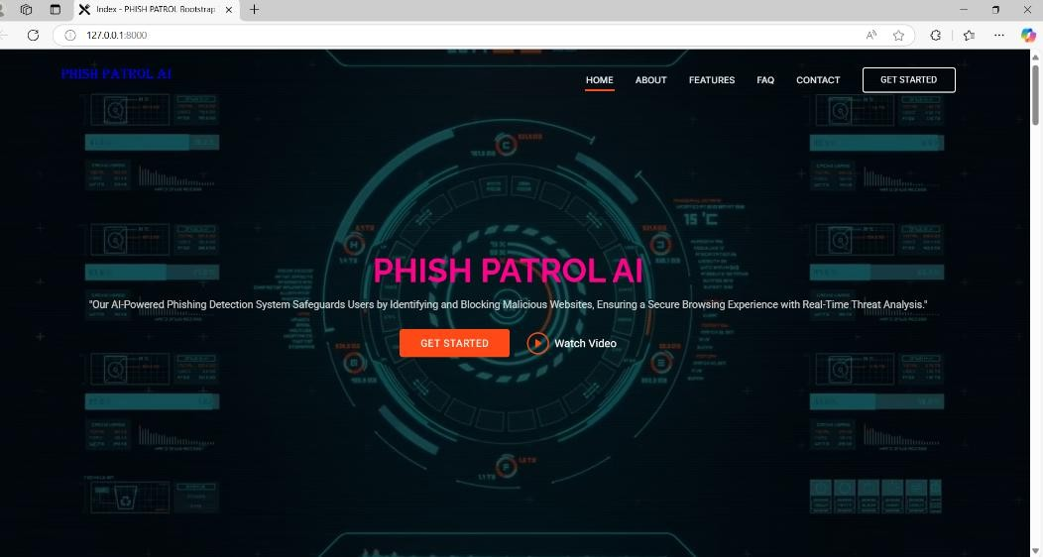

#### Customer Testing

Customer testing involves real end-users interacting with the system to identify usability issues, collect suggestions, and ensure the interface and functionalities meet their expectations.

#### Evaluation

The evaluation phase of the **Phishing Email Detection** project plays a critical role in ensuring the correctness, efficiency, reliability, and robustness of the developed system. It involves thoroughly analyzing the software product from multiple dimensions — code quality, system behavior, and performance under varying conditions. The goal of evaluation is to identify defects, verify functionalities, and assess the system’s ability to meet user expectations and project requirements.

### Performance and evaluation

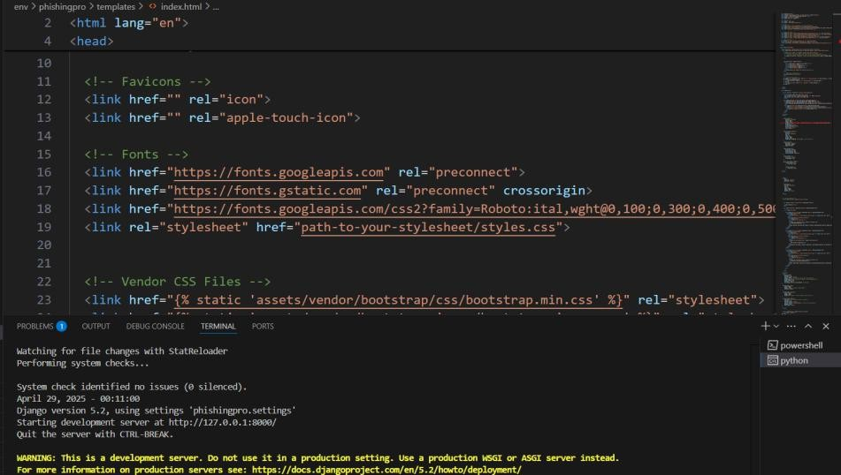

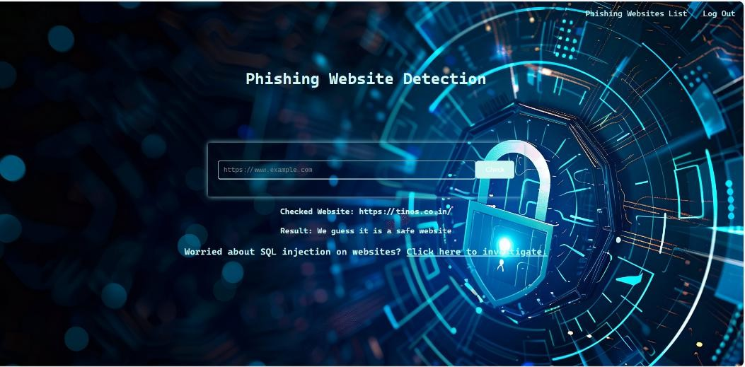

###### Static Code Analysis OVERVIEW

Performed to identify code quality issues, inefficiencies, and vulnerabilities. **Static Code Analysis** is the process of examining source code without executing it, typically to identify potential errors, code smells, vulnerabilities, or adherence to coding standards. It is a key part of **early-stage software quality assurance** that helps detect issues before the software is run.

##### TEST OF MAIN FUNCTION

Evaluation of the detection system's core classification functionality based on metrics such as:

* + - * Precision
      * Recall
      * F1-Score
      * Overall Accuracy

1. SNAPSHOTS OF THE PROJECT

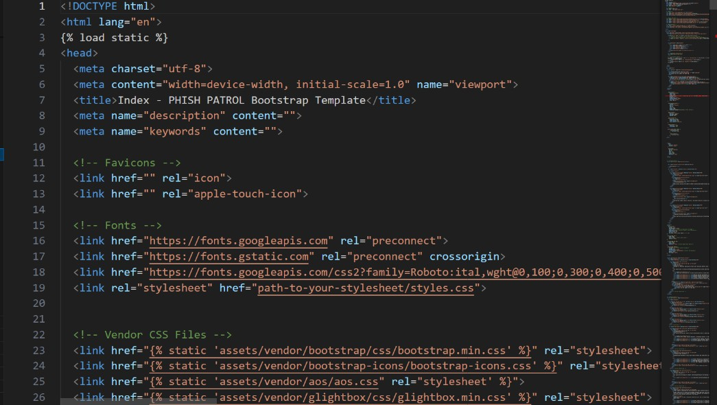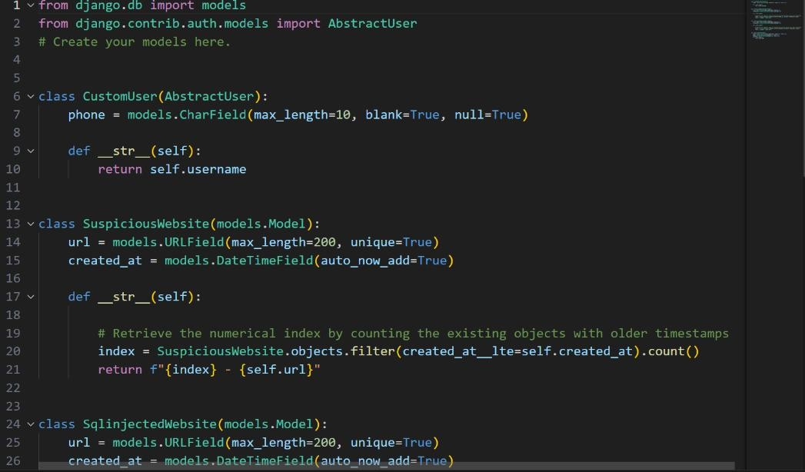

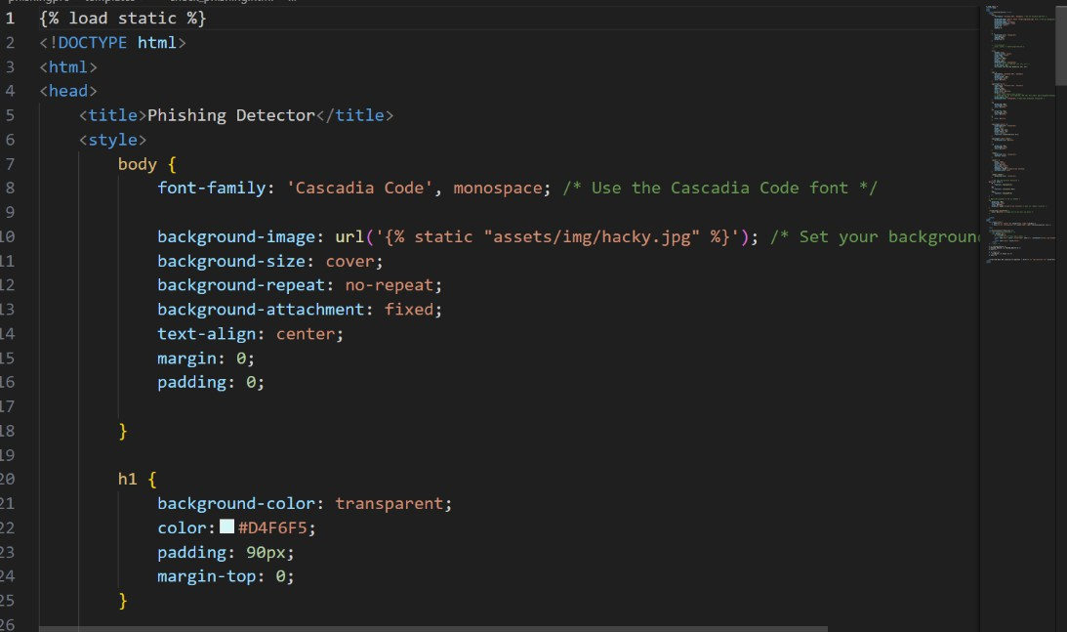

GUI

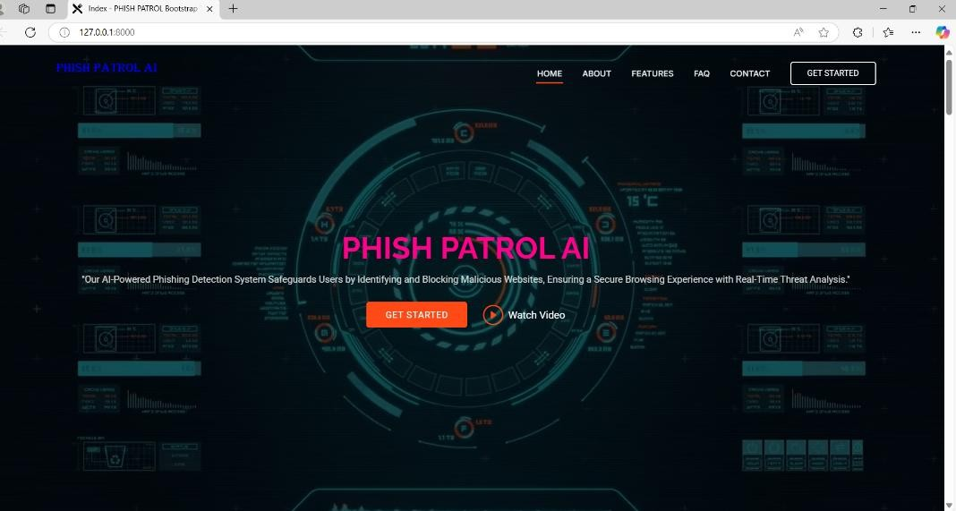

OUTPUT

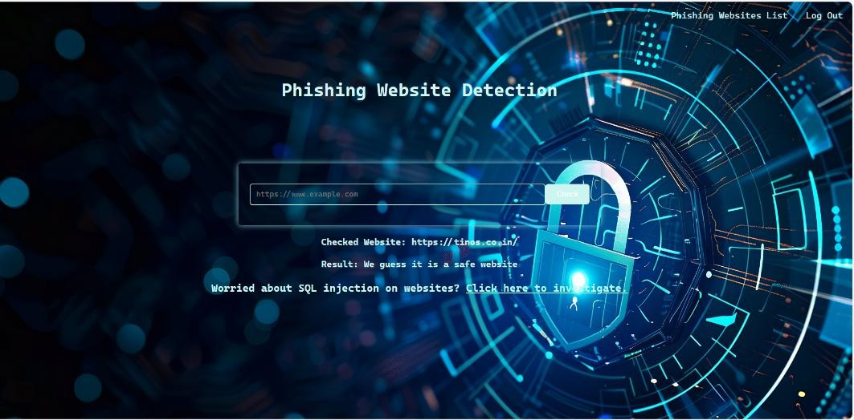

##### CONCLUSIONS

The Phishing Email Detection project successfully demonstrates the potential of Machine Learning in enhancing cybersecurity. It provides an efficient, accurate, and scalable solution for identifying phishing threats, ensuring user safety, and minimizing manual intervention.

#### The completion of this software testing project marks a significant step toward ensuring the reliability, functionality, security, and usability of the application under review. Through a structured and comprehensive test plan, all critical aspects of the system were methodically evaluated, ranging from basic functionality to performance under load and real-world user scenarios.

Static code analysis enabled early detection of code-level issues, ensuring that the development team maintained clean, maintainable, and secure code. Functional and system testing validated that all modules and features met the defined requirements and worked cohesively within the integrated environment. Security testing highlighted and addressed vulnerabilities, safeguarding both the application and user data against potential threats.

1. **FURTHER DEVELOPMENT AND RESEARCH**

### Enhance Test Automation and CI/CD Integration

Develop more intelligent and comprehensive automated testing suites integrated with continuous integration/continuous deployment (CI/CD) pipelines to improve efficiency and reduce manual effort.

### Adopt AI and Machine Learning in Quality Assurance

Leverage AI/ML techniques for predictive defect detection, intelligent test case generation, and test optimization to improve accuracy and reduce testing time.

### Advance Security Testing Practices

#### Strengthen security through regular vulnerability assessments, integration of modern static and dynamic analysis tools, and proactive threat modeling for evolving cybersecurity risks.

1. **Improve User Experience Through Usability and Accessibility Testing** Conduct extensive user-centric evaluations to refine user interface design, ensure accessibility compliance, and enhance overall user satisfaction.

### Explore Scalable and Resilient System Architectures

#### Investigate micro services, cloud-native design, and containerization to improve system scalability, fault tolerance, and performance under high-demand conditions.

##### REFERENCES

1. OpenAI. (2024). *ChatGPT (Version GPT-4)* [Large language model]. [https://chat.openai.com](https://chat.openai.com/)
2. ProgrammingKnowledge. (2022). *Software Testing Tutorial for Beginners* [Video]. YouTube.
3. The Testing Academy. (2023). *Automation Testing Full Course* [Video series]. YouTube.
4. OWASP Foundation. (2023). *OWASP Top 10 – Web Application Security Risks*. <https://owasp.org/www-project-top-ten/>
5. ISO/IEC 25010:2011. (2011). *Systems and Software Engineering – Systems and Software Quality Models*. International Organization for Standardization. <https://www.iso.org/standard/35733.html>